Home lab

Matej papaj

2025

Information about the steps taken

Personal work

2025  Košice | Riešiteľ:  Matej Papaj

Introduction
This document provides details about the setup and configuration of my home server. It includes hardware specifications, operating system installation, services, configurations, and lessons learned during the process. It is also a replacement for the old notebook that was used before hand.

Hardware specifications
Device | Tabletop PC
CPU | Intel(R) Xeon(R) CPU E5-2682 v4 @ 2.50GHz
Motherboard | Intel X99-H5 (temporary)
Memory | 32GB ECC DDR4
NVMe | Apacer AS2280P4 512GB
HDD | 2TB
GPU | GK208B [GeForce GT 730]
More info using lshw

OS
PRETTY_NAME | Ubuntu 24.04.3 LTS
NAME | Ubuntu
VERSION_ID | 24.04
ID | ubuntu
ID_LIKE | debian
HOME_URL | https://www.ubuntu.com/
PRIVACY_POLICY_URL | https://www.ubuntu.com/legal/terms-and-policies/privacy-policy

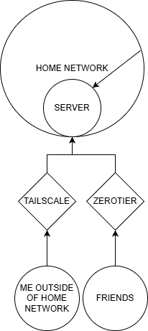
Network
The access to the server is managed through three
ways.
First is home network the access there is unrestricted,
then we have 2 access points with tunnel VPN. One personal
that is TailScale also the access is unrestricted and lastly
ZeroTier used for friends when hosting games.

Setup

Home network
Nothing

Tailscale
Install:
curl –fsSL https://tailscale.com/install.sh | sh
sudo tailscale up
The output will display a URL that you can use to authenticate to your Tailscale network (known as a tailnet). After you authenticate, check the Machines page of the admin console to confirm the device appears in your tailnet.

ZeroTier
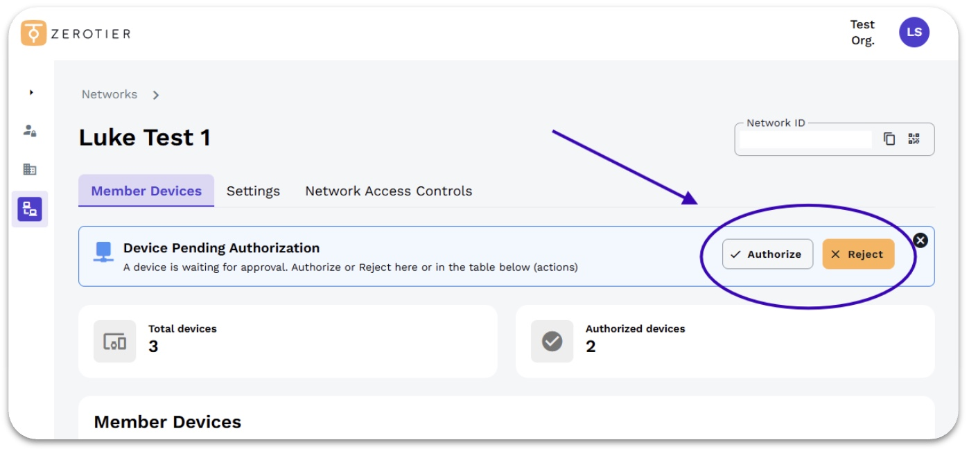
Install:
curl -s https://install.zerotier.com | sudo bash
sudo zerotier-cli join NETWORK_ID
When a device joins, you have two options:
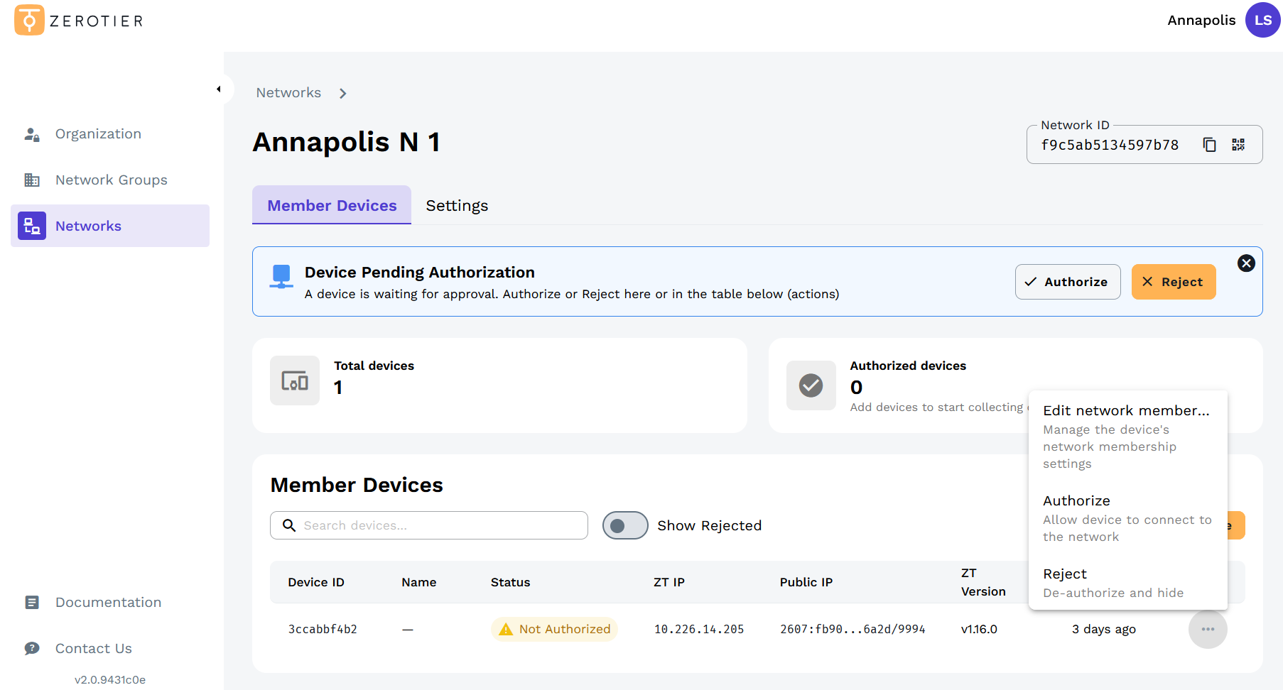
Option 1: Respond to the notification
A notification pop-up will appear when a device joins
Click Authorize in the notification popup

Option 2: Manage devices directly (Recommended)
Go to the Member Devices tab
Click on the device or use the menu to authorize
Afterwards the UFW needs to be configured to block all port except the ones for the game.

K3s
Install:
$ curl -sfL https://get.k3s.io | sh -
$ k3s server --write-kubeconfig-mode=644
Rancher:
install helm (to make rancher work):
$ curl –fsSL –o get_helm.sh https://raw.githubusercontent.com/helm/helm/main/scripts/get-helm-4
$ chmod 700 get_helm.sh
$ ./get_helm.sh

$ helm repo add rancher-latest https://releases.rancher.com/server-charts/latest
$ kubectl create namespace cattle-system
$ kubectl apply -f https://github.com/cert-manager/cert-manager/releases/download/<VERSION>/cert-manager.crds.yaml
$ helm repo add jetstack https://charts.jetstack.io
$ helm repo update
$ helm install cert-manager jetstack/cert-manager \
--namespace cert-manager \
--create-namespace

Games servers

Vintage story
Create /game_servers/vintage_story
sudo mkdir -p /game_servers/vintage_story
sudo chown -R 1000:1000 /game_servers/vintage_story
sudo chmod -R 755 /game_servers/vintage_story

Add to hdd lv:
sudo mount /dev/vg0/game-servers /game_servers
sudo blkid /dev/vg0/game-servers
sudo vim /etc/fstab
UUID=ID /game_servers ext4 defaults 0 2

Create these 3 files exactly:
1. manual-sc.yaml
apiVersion: storage.k8s.io/v1
kind: StorageClass
metadata:
name: manual
provisioner: kubernetes.io/no-provisioner
volumeBindingMode: WaitForFirstConsumer
2. pv-pvc.yaml
apiVersion: v1
kind: PersistentVolume
metadata:
name: vintage-story-pv
spec:
capacity:
storage: 50Gi
accessModes:
- ReadWriteOnce
storageClassName: manual
persistentVolumeReclaimPolicy: Retain
hostPath:
path: /game_servers/vintage_story
type: DirectoryOrCreate
---
apiVersion: v1
kind: PersistentVolumeClaim
metadata:
name: vintage-story-pvc
spec:
accessModes:
- ReadWriteOnce
storageClassName: manual
resources:
requests:
storage: 50Gi
3. statefulset.yaml
apiVersion: apps/v1
kind: StatefulSet
metadata:
name: vintage-story
spec:
serviceName: vintage-story
replicas: 1
selector:
matchLabels:
app: vintage-story
template:
metadata:
labels:
app: vintage-story
spec:
containers:
- name: vintage-story
image: zsuatem/vintagestory:1.21.6
ports:
- containerPort: 42420
resources:
requests:
cpu: "4"
memory: "8Gi"
limits:
cpu: "8"
memory: "16Gi"
volumeMounts:
- name: world-data
mountPath: /vintagestory/data
volumes:
- name: world-data
persistentVolumeClaim:
claimName: vintage-story-pvc
---
apiVersion: v1
kind: Service
metadata:
name: vintage-story
spec:
type: NodePort
selector: app: vintage-story
ports:
- port: 42420
targetPort: 42420
nodePort: 32420
Execute these commands in order:
1. Apply StorageClass, PV, PVC
$ sudo kubectl apply -f manual-sc.yaml
$ sudo kubectl apply -f pv-pvc.yaml
2. Verify PV/PVC bound
$ sudo kubectl get pv,pvc
3. Apply StatefulSet + Service
$ sudo kubectl apply -f statefulset.yaml
4. Verify pod running
$ sudo kubectl get pods
5. Test 2-way sync
$ sudo kubectl exec -it vintage-story-0 -- touch /vintagestory/data/pod-test
$ ls –la /game_servers/vintage_story/pod-test
$ touch /game_servers/vintage_story/host-test
$ sudo kubectl exec vintage-story-0 -- ls /vintagestory/data/host-test

Services

Jellyfin
Make these:
/services - lv_services – 100G
/movies - lv_movie – 1T
own 1000:1000 on both
jelly.yaml:
apiVersion: v1
kind: Namespace
metadata:
name: jellyfin
---
apiVersion: apps/v1
kind: Deployment
metadata:
name: jellyfin
namespace: jellyfin
spec:
replicas: 1
selector:
matchLabels:
app: jellyfin
template:
metadata:
labels:
app: jellyfin
spec:
containers:
- name: jellyfin
image: jellyfin/jellyfin:latest
env:
- name: PUID
value: "1000"
- name: PGID
value: "1000"
- name: TZ
value: "Europe/Bratislava"
ports:
- containerPort: 8096
name: http
volumeMounts:
- name: config
mountPath: /config
- name: media
mountPath: /media
volumes:
- name: config
hostPath:
path: /services/jellyfin
type: DirectoryOrCreate
- name: media
hostPath:
path: /movies
type: Directory
---
apiVersion: v1
kind: Service
metadata:
name: jellyfin
namespace: jellyfin
spec:
selector:
app: jellyfin
type: NodePort # Changed from ClusterIP
ports:
- port: 8096
targetPort: 8096
protocol: TCP
name: http
nodePort: 30096 # Fixed high port (30000-32767 range); auto-assigned if omitted
Create a script (e.g., /usr/local/bin/iptables-startup.sh):
#!/bin/bash
iptables -t raw -I PREROUTING 1 -p tcp --dport 30096 -j DROP
iptables -t raw -I PREROUTING 1 -s 192.168.0.0/24 -p tcp --dport 30096 -j ACCEPT
iptables -t raw -I PREROUTING 1 -s 100.64.0.0/10 -p tcp --dport 30096 -j ACCEPT
Then:
$ sudo chmod +x /usr/local/bin/iptables-startup.sh
Create /etc/systemd/system/iptables-startup.service:
[Unit]
Description=Custom iptables rules
After=network.target
[Service]
Type=oneshot
ExecStart=/usr/local/bin/iptables-startup.sh
RemainAfterExit=yes
[Install]
WantedBy=multi-user.target
Enable and start the service:
$ sudo systemctl daemon-reload
$ sudo systemctl enable iptables-startup.service
$ sudo systemctl start iptables-startup.service

Pomodoro
mv html to /services/pomodoro/
index.html
style.css
script.js
favicon.ico
there do:
$ sudo kubectl create configmap pomodoro-web --from-file=index.html --from-file=style.css --from-file=script.js --from-file=favicon.ico
make a deployment.yaml:
apiVersion: apps/v1
kind: Deployment
metadata:
name: pomodoro
spec:
replicas: 1
selector:
matchLabels:
app: pomodoro
template:
metadata:
labels:
app: pomodoro
spec:
containers:
- name: nginx
image: nginx:alpine
ports:
- containerPort: 80
volumeMounts:
- name: website
mountPath: /usr/share/nginx/html
volumes:
- name: website
configMap:
name: pomodoro-web
---
apiVersion: v1
kind: Service
metadata:
name: pomodoro
spec:
type: NodePort
selector:
app: pomodoro
ports:
- port: 80
targetPort: 80
nodePort: 30808
and:
$ sudo kubectl apply -f pomodoro.yaml
Create or adjust a script (e.g., /usr/local/bin/iptables-startup.sh):
#!/bin/bash
iptables -t raw -I PREROUTING 1 -p tcp --dport 30808 -j DROP
iptables -t raw -I PREROUTING 1 -s 192.168.0.0/24 -p tcp --dport 30808 -j ACCEPT
iptables -t raw -I PREROUTING 1 -s 100.64.0.0/10 -p tcp --dport 30808 -j ACCEPT
Then:
$ sudo chmod +x /usr/local/bin/iptables-startup.sh
Create /etc/systemd/system/iptables-startup.service:
[Unit]
Description=Custom iptables rules
After=network.target
[Service]
Type=oneshot
ExecStart=/usr/local/bin/iptables-startup.sh
RemainAfterExit=yes
[Install]
WantedBy=multi-user.target
Enable and start the service:
$ sudo systemctl daemon-reload
$ sudo systemctl enable iptables-startup.service
$ sudo systemctl start iptables-startup.service

More information to all
Tailscale - https://tailscale.com/kb/1031/install-linux
Zerotier - https://www.zerotier.com/download/
https://docs.zerotier.com/quickstart/
K3s - https://docs.k3s.io/quick-start
Rancher - https://ranchermanager.docs.rancher.com/getting-started/quick-start-guides/deploy-rancher-manager/helm-cli

